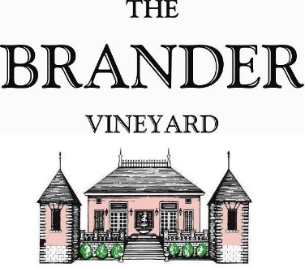

2023 au Naturel Sauvignon Blanc, Estate, LOD

This reserve Sauvignon Blanc bottling was produced entirely from grapes grown here on our estate. Our favorite lot from the vintage is selected based on aromatics, concentration, and acidity. Stainless steel fermentation and sur-lie aging results in a richer mouthfeel, compelling minerality, luscious flavors, and the age-ability for which this wine is renowned.

**Technical Information:**

Cases Produced: 403

Composition: 100% Sauvignon Blanc

Vineyard Sources: Brander Vineyard, Estate, Los Olivos District

Harvest Date: 09/13, 09/19, 09/20, 09/28

Chemistry at Harvest (respectively): Brix: 23.6, pH: 3.34

Brix: 23.9, pH: 3.32

Brix: 24.1, pH: 3.32

Brix: 24.4, pH: 3.47

Alcohol: 14.3%

Winemaking: Organic Practices in the vineyard (not certified). All grapes were hand harvested. Fruit was destemmed and crushed and allowed approximately 0.5-2.0 hour skin contact before pressing. Only the free run juice was used for this bottling. Wine was fermented and aged in stainless for approximately 9 months and malolactic fermentation was prevented. Aged on lees for approximately 8 months before racking.

Bottling Date: 06/24/2024