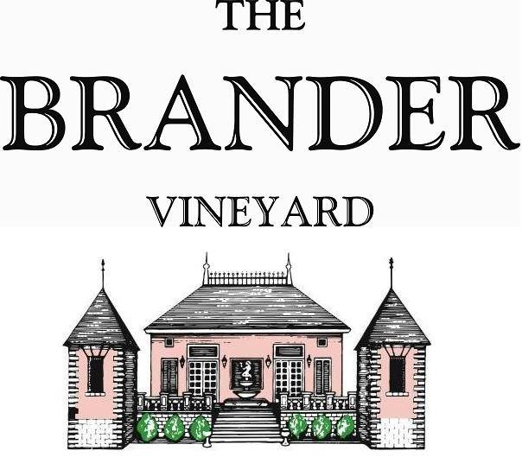

2023 Sauvignon Gris, Estate, Los Olivos District

Fred Brander acquired the cuttings in Bordeaux to plant one acre of estate Sauvignon Gris in 1990. This is one of the first vineyards in California to grow it. This bottling is a beautiful example of this rare, rose-skinned variety. This wine pairs perfectly with fresh shellfish, ceviche, or an arugula salad.

**Technical Information:**

Cases Produced: 45

Composition: 100% Sauvignon Gris

Vineyard Sources: Brander Vineyard, Estate, Los Olivos District

Harvest Dates: Sauvignon Blanc: 10/06

Chemistry at Harvest: 23.4° Brix, ph=3.40

Alcohol: 14.1%

Winemaking: Organic Practices in the vineyard (not certified). All grapes were hand harvested. Fruit was destemmed and crushed and allowed approximately 0.5 hour skin contact before pressing. Only the free run juice was used for this bottling. Wine was fermented and aged in stainless and malolactic fermentation was prevented.

Bottling Date: 06/24/24