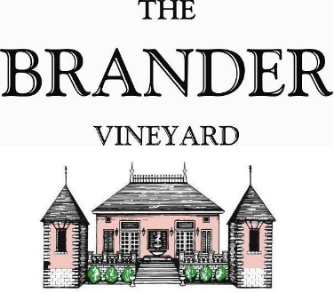

2023 Mesa Verde Vineyard Sauvignon Blanc, LOD

This Sauvignon Blanc bottling was produced from grapes grown at Mesa Verde Vineyard which is less than 5 miles south of the estate vineyard. We have been working with this vineyard and making a vineyard designate since 2005. The deliciously textured palate shows hints of quince and lemongrass.

**Technical Information:**

Cases Produced: 389

Composition: 100% Sauvignon Blanc

Vineyard Sources: Mesa Verde Vineyard, Los Olivos District

Harvest Date: 10/05, 10/13, 10/16

Chemistry at Harvest: Brix: 24.2-25.5 pH: 3.20-3.30

Alcohol by Volume: 14.5%

Winemaking: Organic Practices in the vineyard (not certified). All grapes were hand harvested. Fruit was destemmed and crushed and allowed approximately 0.5-1.0 hour skin contact before pressing. Only the free run juice was used for this single vineyard designate. Wine was fermented and aged in stainless for approximately 6 months. Malolactic fermentation was prevented.

Bottling Date: 04/02/2024