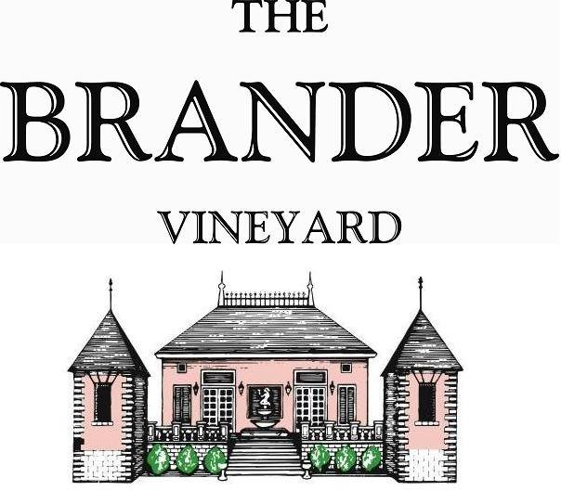

2023 Estate Le Cul de Refugio, LOD

In addition to producing Bordeaux style varieties, every year we also produce small lots of other varieties grown primarily on the estate. This cuvee, blending Pinot Blanc, Pinot Gris, and Chardonnay, reflects what we stylistically achieve in our Sauvignon Blanc.

**Technical Information:**

Cases Produced: 50 cases

Composition: 45% Pinot Gris ,38% Pinot Blanc, 17% Chardonnay

Vineyard Sources: Brander Vineyard (Estate), Los Olivos District

Harvest Date: 10/04 for all varietals (Pinot Gris, Pinot Blanc, Chardonnay)

Chemistry at Harvest for blended juice: Brix: 23.9, pH: 3.46

Alcohol: 14.1% By Volume

Winemaking: Organic Practices in the vineyard (not certified). All grapes were hand harvested. Fruit was destemmed and crushed and allowed approximately 0.5-1.0 hour skin contact before pressing. Only the free run juice was used for this single vineyard designate. Wine was fermented and aged (7 months) in neural French barrels. Malolactic fermentation was prevented.

Bottling Date: 06/24/24