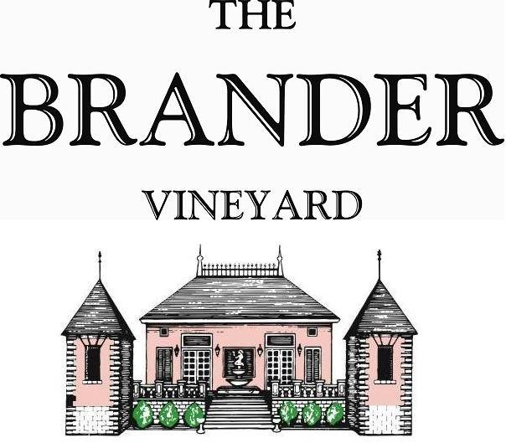

2023 Sauvignon Blanc, Los Olivos District

The Sauvignon Blanc is sourced from our estate vineyard in Los Olivos as well as a number of other carefully farmed vineyards with the Los Olivos AVA. This is over 50% of Brander's entire production and is the most popular wine. We are also celebrating our 47th year of harvest with this vintage. A remarkable value, this vintage is brimming with bright refreshing notes of grapefruit and nectarine.

**Technical Information:**

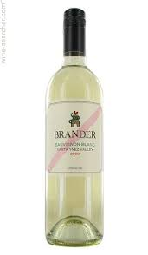Cases Produced: 8,000

Composition: 92% Sauvignon Blanc, 3% Muscat, 2% Pinot Gris, 2% Riesling, 0.5% Semillon, 0.5% Petit Manseng

Vineyard Sources: Brander Estate, Mesa Verde, La Presa, Kick On, Lucas and Lewellen, Nolan, Gainey, Buttonwood

Harvest Dates: 09/08 – 10/30

Chemistry at Harvest: Average Brix: 23.5, Average pH: 3.35

Alcohol: 13.5% by Volume

Winemaking: All grapes were hand harvested. Fruit was destemmed and crushed and allowed approximately 0.5-1.0 hour skin contact before pressing. Wine was fermented in stainless and malolactic fermentation was prevented. The wine was mostly aged in stainless steel with only approximately 5% in neutral French oak.

Bottling Date: 02/08/24