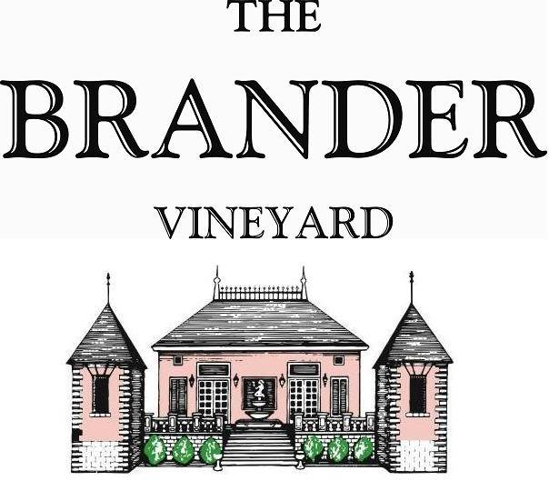

2023 Los Olivos District Rosé

The Brander rosé is a unique blend of Merlot and Cabernet Sauvignon which are the red Bordeaux varietals we are known for. This year we added Malbec, Syrah, and Cabernet Franc as well. We intentionally pick the grapes selected for rosé earlier than we would for red wine. The result is a rosé that has refreshing acidity, lower alcohol, and beautiful red berry fruit character. It is an easy drinking wine to enjoy without food yet has enough concentration and layers to pair with food.

**Technical Information:**

Cases Produced: 630

Composition: 60% Merlot, 25% Cabernet Sauvignon, 8% Cabernet Franc, 4% Malbec, 3% Syrah

Vineyard Sources: Mesa Verde Vineyard – Merlot

Brander Vineyard (Estate) – Cabernet Sauvignon, Cabernet Franc, Merlot, Malbec, and Syrah

Harvest Dates and Chemistry at Harvest: Brix pH

10/23 Mesa Verde Merlot 24.1 3.49

10/20 Estate Merlot 23.4 3.55

10/18 Estate Syrah 24.2 3.57

10/20 Cabernet Sauvignon 22.3 3.33

09/26 Cabernet Franc 20.8 3.23

10/20 Malbec 21.4 3.36

Alcohol by Volume: 13.5%

Winemaking: All grapes were hand harvested for the intention of making rosé. Fruit was destemmed and crushed and allowed approximately 1-2 hours skin contact before pressing. Wine was fermented and aged in stainless for about 3 months. Malolactic fermentation was prevented.

Bottling Date: 02/09/2024