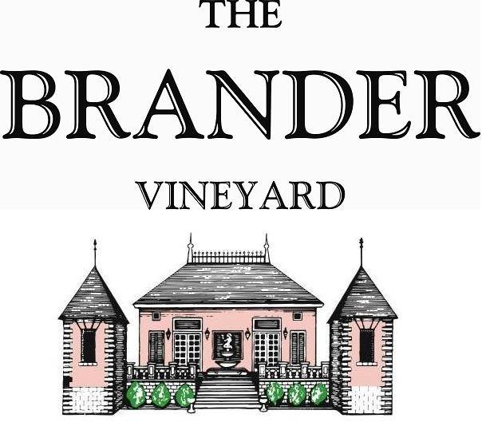

2023 Kick-On Vineyard Riesling, SBC

Kick On Vineyard has developed a reputation for growing great Riesling. Our 2023 bottling has green apple aromas, exciting acidity, tangerine and apricot flavors, and nice long finish.

**Technical Information:**

Cases Produced: 45 cases

Composition: 100% Riesling

Vineyard Sources: Kick On Vineyard, Santa Barbara County

Harvest Dates: 10/26

Chemistry at Harvest: Brix: 22.6 pH: 3.14

Alcohol by Volume: 12.5%

Winemaking: All grapes were hand harvested. Fruit was destemmed and crushed and allowed approximately 0.5-1.0 hour skin contact before pressing. Only the free run juice was used for this single vineyard designate. Wine was fermented and aged in stainless for approximately 5 months. Malolactic fermentation was prevented.

Bottling Date: 04/03/24