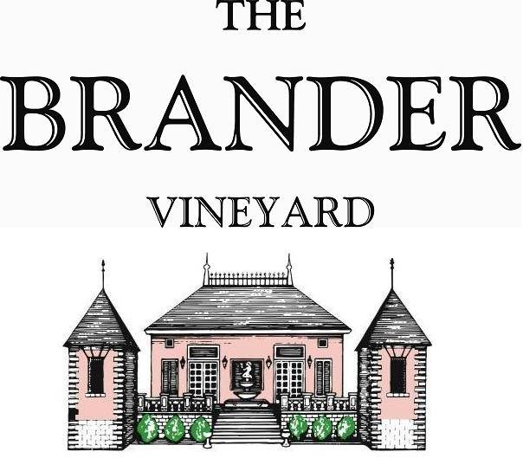

2023 Cuvee Nicolas Sauvignon Blanc, Estate, LOD

The majority of the Sauvignon Blanc we produce is fermented and aged in the stainless steel. Our Cuvée Nicolas is an exception. We select grapes from the Estate with the perfect balance of richness and acidity to make this wine.

**Technical Information:**

Cases Produced: 146

Composition: 100% Sauvignon Blanc

Vineyard Sources: Brander Vineyard, Estate, Los Olivos District

Harvest Date: 09/28, 09/29, 10,02

Chemistry at Harvest (respectively): Brix: 24.4, pH: 3.47 Brix: 25.1, pH: 3.53

Brix: 25.8, pH: 3.55

Alcohol: 14.9%

Winemaking: Organic Practices in the vineyard (not certified). All grapes were hand harvested. Fruit was destemmed and crushed and allowed approximately 0.5-1.0 hour skin contact before pressing. Only the free run juice was used for this bottling. Wine was fermented and aged in 225L French Oak Barrels (20% new) for 8 months. Lees were stirred a couple of times a week for one month but allowed the lees to remain in contact with the wine for the entirety of the barrel aging period. Malolactic fermentation was prevented.

Bottling Date: 06/24/24