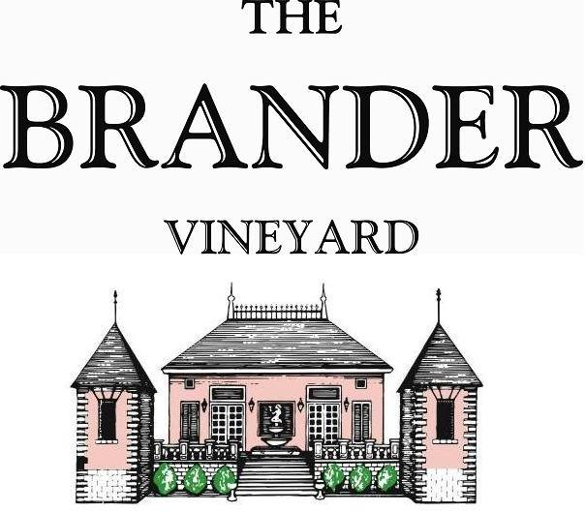

2023 Cuvée Natalie, Santa Barbara County

This perennial favorite, named after owner and winemaker, Fred Brander’s late daughter, is a blend of 41% Sauvignon Blanc, 32% Pinot Gris, and 27% Riesling. This shows a very pale gold in the glass and opens with aromas of Anjou pear, white nectarines, and honeysuckle.

**Technical Information:**

Cases Produced: 155 cases

Composition: 41% Sauvignon Blanc, 32% Pinot Gris, and 27% Riesling

Vineyard Sources: Sauvignon Blanc - Brander Vineyard, Estate, Los Olivos District

Pinot Gris and Riesling – Kick On Vineyard, Santa Barbara County

Harvest Dates: Sauvignon Blanc: 09/20, Pinot Gris: 10/11, Riesling: 10/26

Chemistry at Harvest: Sauvignon Blanc: Brix: 24.1 pH: 3.32

Pinot Gris: Brix: 24.5 pH: 3.37

Riesling: Brix: 22.6 pH: 3.14

Alcohol by Volume: 13.8%

Winemaking: All grapes were hand harvested. Fruit was destemmed and crushed and allowed approximately 0.5-1.0 hour skin contact before pressing. Only the free run juice was used for this bottling. Aged for approximately 5 months in 100% stainless steel. Malolactic fermentation was prevented.

Bottling Date: 04/03/24