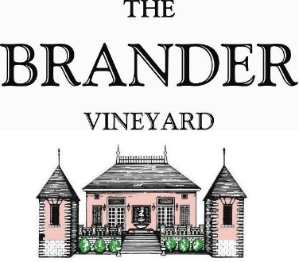

2023 Buttonwood Vineyard Sauvignon Blanc, LOD

It has been a few years since we sourced Sauvignon Blanc from neighboring Buttonwood Vineyard. Their first plantings of Sauvignon Blanc were grafted from The Brander Vineyard in 1983. We are happy to have the opportunity to work with these grapes again.

**Technical Information:**

Cases Produced: 46 cases

Composition: 100% Sauvignon Blanc

Vineyard Sources: Buttonwood Vineyard, Los Olivos District

Harvest Date: 10/05, 10/10

Chemistry at Harvest (respectively): Brix: 24.4, pH: 3.33 Brix: 25.9, pH: 3.40

Alcohol by Volume: 14.5%

Winemaking: All grapes were hand harvested. Fruit was destemmed and crushed and allowed approximately 0.5-1.0 hour skin contact before pressing. Only the free run juice was used for this single vineyard designate. Wine was fermented and aged in stainless for approximately 8 months. Malolactic fermentation was prevented.

Bottling Date: 06/24/2024