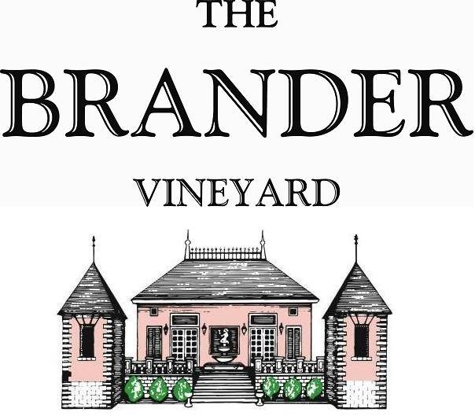

2022 Estate Rosé of Cabernet Sauvignon, LOD

After tasting through the various tank/lots of rosé picked in 2022 we were very impressed with the unique and complete expression of the specific Cabernet Sauvignon tank we used for this wine. Although light salmon in color, this rosé has luscious apricot flavors, nice body, and tannin structure making it enjoyable with food.

**Technical Information:**

Cases Produced: 119 cases

Composition: 100% Cabernet Sauvignon

Vineyard Sources: Brander Vineyard (Estate)

Harvest Date: 10/19

Chemistry at Harvest: Brix: 22.5 pH: 3.49

Alcohol by Volume: 13.6%

Winemaking: Organic Practices in the vineyard (not certified). All grapes were hand harvested for the intention of making rosé. Fruit was destemmed and crushed and allowed approximately 2 hours skin contact before pressing. Wine was fermented and aged in stainless for approximately 3 months. Malolactic fermentation was prevented.

Bottling Date: 01/20/2023