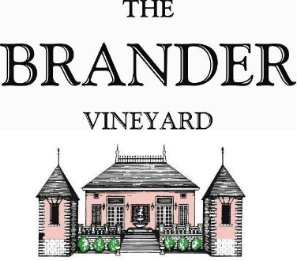

2022 Estate Riesling, LOD

Produced in a dry style, the Estate Riesling has the characteristics and magic of world class Rieslings. It has bright acidity with a kaleidoscope of pear, tropical and red berry fruit and aromas of lemongrass and a whiff of petrol. Exciting and lively mouthfeel.

**Technical Information:**

Cases Produced: 32 cases

Composition: 100% Riesling

Vineyard Sources: Brander Vineyard (Estate), Los Olivos District

Harvest Dates: 10/08

Chemistry at Harvest: Brix: 21.3 pH: 3.40

Alcohol by Volume: 13.0%

Winemaking: Organic Practices in the vineyard (not certified). All grapes were hand harvested. Fruit was destemmed and crushed and allowed approximately 0.5-1.0 hour skin contact before pressing. Only the free run juice was used for this single vineyard designate. Wine was fermented and aged in stainless for approximately 5.5 months. Malolactic fermentation was prevented.

Bottling Date: 03/30/23