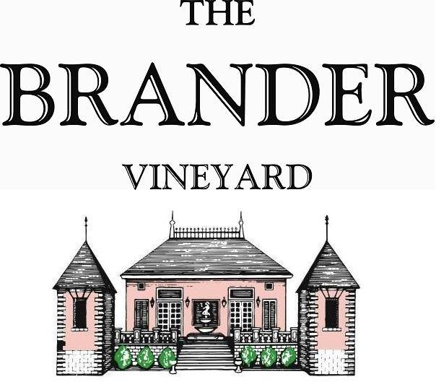

2021 Cabernet Sauvignon, Estate

While the Brander Vineyard has long been renowned for our Sauvignon Blancs, we are also immensely proud of our distinctive, classically Bordeaux-styled Cabernets. This vintage offers gorgeous, pure fruit and presents an attractive, translucent dark ruby in the glass. A nose of ripe strawberry, cherry, and raspberries with a soft velvety finish.

**Technical Information:**

Cases Produced: 658

Composition: 75% Cabernet Sauvignon, 11% Syrah, 7% Malbec, 5% Merlot, 2% Cabernet Franc

Vineyard Sources: 100% Brander Vineyard, Estate

Harvest Dates and Chemistry at Harvest: Brix pH

11/04 Cabernet Sauvignon, Block 3 24.7 3.51

10/28 Cabernet Sauvignon, Block 7 23.3 3.60

10/22 Syrah 25.2 3.57

10/23 Malbec 23.3 3.65

10/23 Merlot 24.5 3.61

11/04 Cabernet Franc 23.9 3.56

Alcohol by Volume: 13.9%

Winemaking: All grapes were hand harvested. Fruit was destemmed and lightly crushed before fermenting in 1.5 ton bins. Wine was then allowed to age in neutral French oak barrels for approximately 19 months.

Bottling Date: 05/31/23