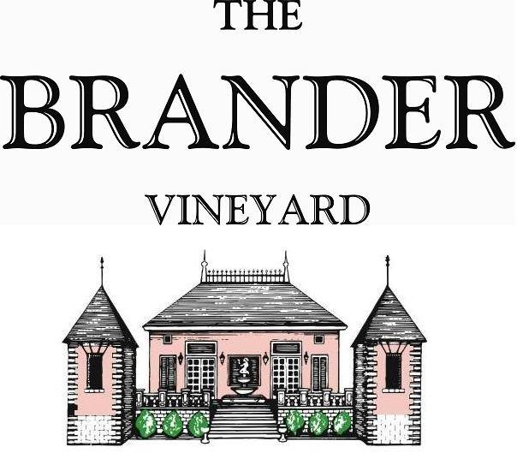

2021 Estate Syrah, LOD

The Los Olivos District has proven to be a great area to grow Syrah. Aromas of violets and clove, and flavors of black cherry.

**Technical Information:**

Cases Produced: 102

Composition: 100% Syrah

Vineyard Sources: Brander Vineyard (Estate), Los Olivos District

Harvest Date: 10/22

Chemistry at Harvest: Brix: 25.2 pH: 3.52

Alcohol by Volume: 15.2%

Winemaking: Organic Practices in the vineyard (not certified). All grapes were hand harvested from a ¾ acre block on the estate. Fruit was destemmed and lightly crushed before fermenting in 1.5 ton bins. Wine was then allowed to age in neutral French oak barrels for approximately 10 months.

Bottling Date: 09/06/22