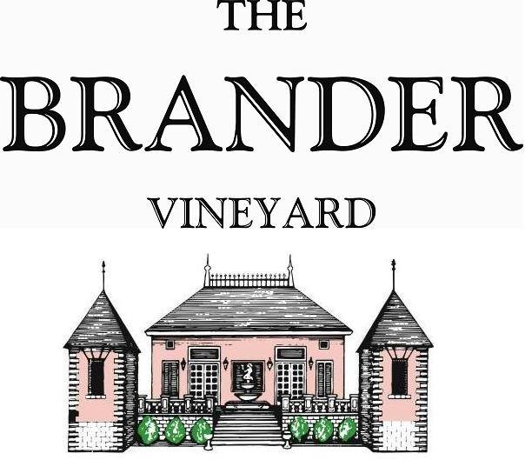

2021 Estate Malbec, LOD

This is our second estate Malbec bottling, and it comes from a one acre block planted in 2015. We purposely thin fruit yield to produce a wine with lots of color and flavor concentration. This rich wine has blueberry, fig pudding, and tobacco note flavors. The massive structure will be the perfect complement to roasted meats, hence the popularity of this varietal in Argentina.

**Technical Information:**

Cases Produced: 49

Composition: 100% Malbec

Vineyard Sources: Brander Vineyard (Estate), Los Olivos District

Harvest Date: 10/23

Chemistry at Harvest: Brix: 23.3 pH: 3.65

Alcohol by Volume: 13.9%

Winemaking: Organic Practices in the vineyard (not certified). All grapes were hand harvested. Fruit was destemmed and lightly crushed before fermenting in 1.5 ton bins. Wine was then allowed to age in neutral French oak barrels for 21 months.

Bottling Date: 08/22/23