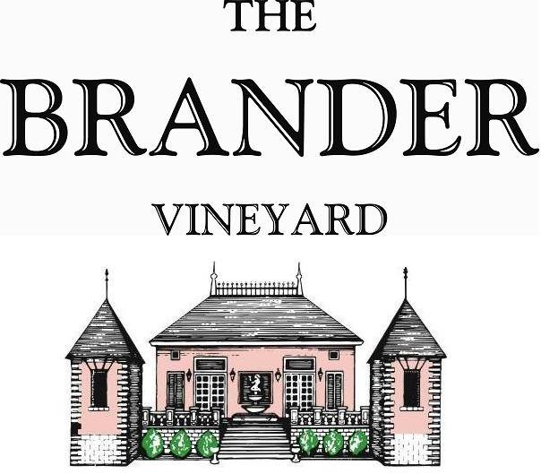

2021 Estate Cabernet Franc, LOD

The Brander Vineyard was the first winery in Santa Barbara County to plant Cabernet Franc. This bottling was produced from the original 1976 planting. It demonstrates Cabernet Franc’s exotic herbal perfume and firm structure. Deep garnet color and aromas of violets, lilacs, and dried currants.

**Technical Information:**

Cases Produced: 48

Composition: 100% Cabernet Franc

Vineyard Sources: Brander Vineyard (Estate), Los Olivos District

Harvest Date: 11/04

Chemistry at Harvest: Brix: 23.9 pH: 3.56

Alcohol by Volume: 13.8%

Winemaking: Organic Practices in the vineyard (not certified). All grapes were hand harvested. Fruit was destemmed and lightly crushed before fermenting in 1.5 ton bins. Wine was then allowed to age in neutral French oak barrels for 21 months.

Bottling Date: 08/22/23