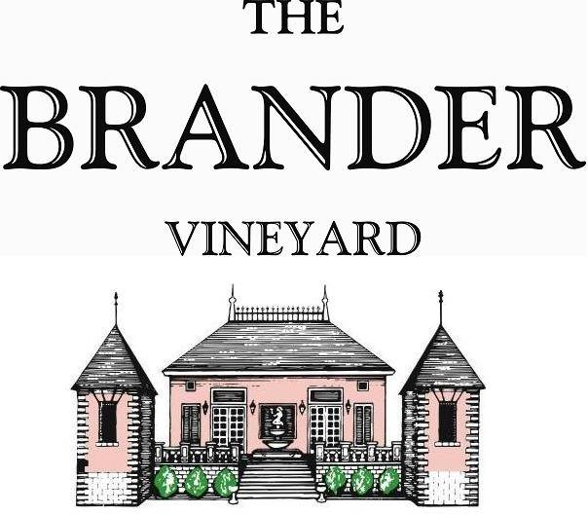

2020 Cabernet Sauvignon Reserve, Estate, LOD

For our Cabernet Sauvignon Reserve, we carefully select only the barrels of the vintage from our estate vineyard and blend them together to create a wine of elegance, structure, and grace. It has a vibrant, cool climate bouquet of ripe blackberries and mulberries as well as sappy herbs, mint, tobacco, and graphite.

**Technical Information:**

Cases Produced: 71

Composition: 100% Cabernet Sauvignon

Vineyard Sources: Brander Vineyard, Estate, Los Olivos District

Harvest Dates: 10/16 and 10/20

Chemistry at Harvest respectively: Brix: 24.2, pH: 3.91 Brix: 25.6, pH: 3.66

Alcohol by Volume: 14.5%

Winemaking: Organic Practices in the vineyard (not certified). All grapes were hand harvested. Two thirds of the grapes are from un-grafted vines planted in 1975. Fruit was destemmed and lightly crushed before fermenting in 1.5 ton bins. Wine was then allowed to age in French oak barrels (66% new) for 19 months.

Bottling Date: 07/26/22