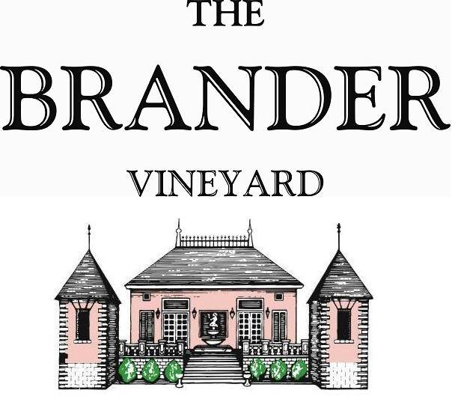

2019 Estate Merlot, LOD

Our first estate bottling since 2004, the 2019 estate Merlot was produced from one acre block planted in 2015. Full bodied with the color and flavor of ripe plums. Aromas of wild blackberries, cola, cocoa, and violets. Long and silky finish.

**Technical Information:**

Cases Produced: 74

Composition: 100% Merlot

Vineyard Sources: Brander Vineyard (Estate), Los Olivos District

Harvest Date: 10/04

Chemistry at Harvest: Brix: 26.1 pH: 3.50

Alcohol by Volume: 14.7%

Winemaking: Organic Practices in the vineyard (not certified). All grapes were hand harvested from younger vines planted in 2016. Fruit was destemmed and lightly crushed before fermenting in 1.5 ton bins. Wine was then allowed to age in neutral French oak barrels for 14 months.

Bottling Date: 01/15/21