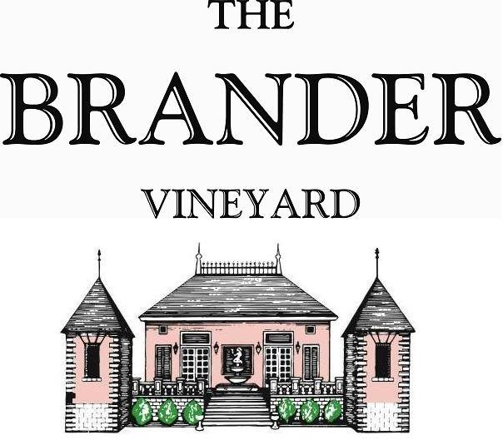

2019 Bouchet, Estate Red Wine Blend, LOD

Bouchet is slang word for both Cabernet Sauvignon and Cabernet Franc in different areas of Bordeaux region. The first bottling of this blend was in 1984, which resulted in the first Meritage blend in Santa Barbara County. Cabernet Franc is from un-grafted vines planted in 1976. Cabernet Sauvignon was planted in 2008 and Merlot in 2016. This powerful and smooth Bordeaux style blend reflects the focus of Cabernet Sauvignon and spicy aromatics of Cabernet Franc, with additional body with fruit of Merlot. Flavors of plum, grape, and boysenberry.

**Technical Information:**

Cases Produced: 120

Composition: 60% Cabernet Sauvignon, 20% Cabernet Franc, 20% Merlot

Vineyard Sources: Brander Vineyard (Estate), Los Olivos District

Harvest Date: Cabernet Sauvignon – 10/25

Cabernet Franc – 10/24

Merlot – 10/04

Chemistry at Harvest: Cabernet Sauvignon - Brix: 26.2, pH: 3.63

Cabernet Franc - Brix: 27.0, pH: 3.70

Merlot – Brix: 26.1, pH: 3.70

Alcohol by Volume: 14.8%

Winemaking: Organic Practices in the vineyard (not certified). All grapes were hand harvested. Fruit was destemmed and lightly crushed before fermenting in 1.5 ton bins. Wine was then allowed to age in French oak barrels (20% new) for 14 months.

Bottling Date: 01/15/21